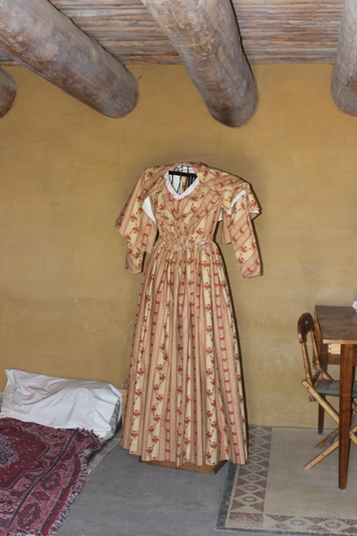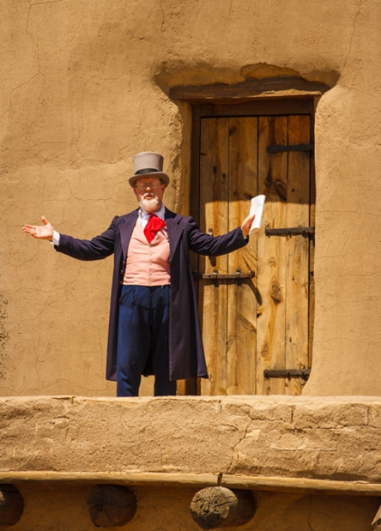

Photo of Anglo merchant re-enactor Photo of 1840s eastern U.S. dress

in eastern U.S. 1840’s style (generally worn by Anglo women)

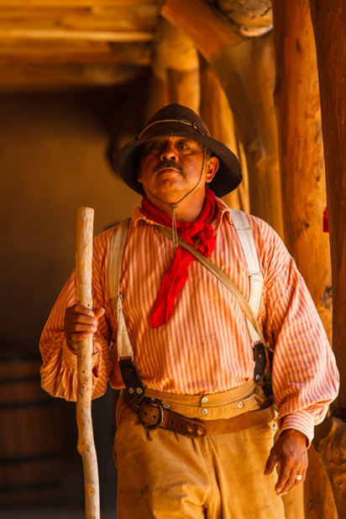

Photo of Mexican herder re-enactor

Mexican with felt hat, scarf, buckskin shirt and pants holding a horse whip and leading a saddled black horse through an adobe corral


Photo of Mexican vaquero re-enactor

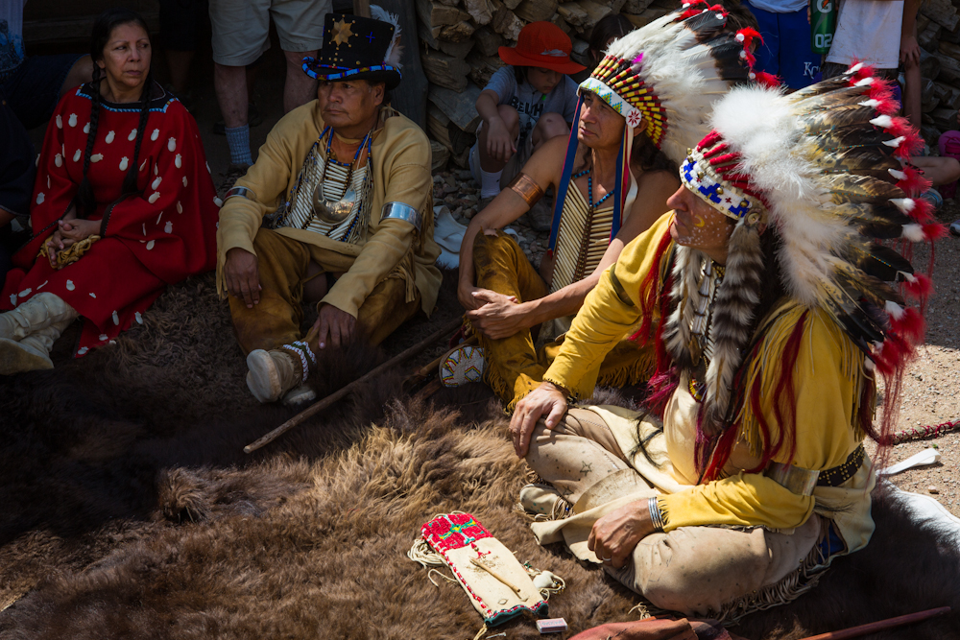

Plains Indian Council re-enactors

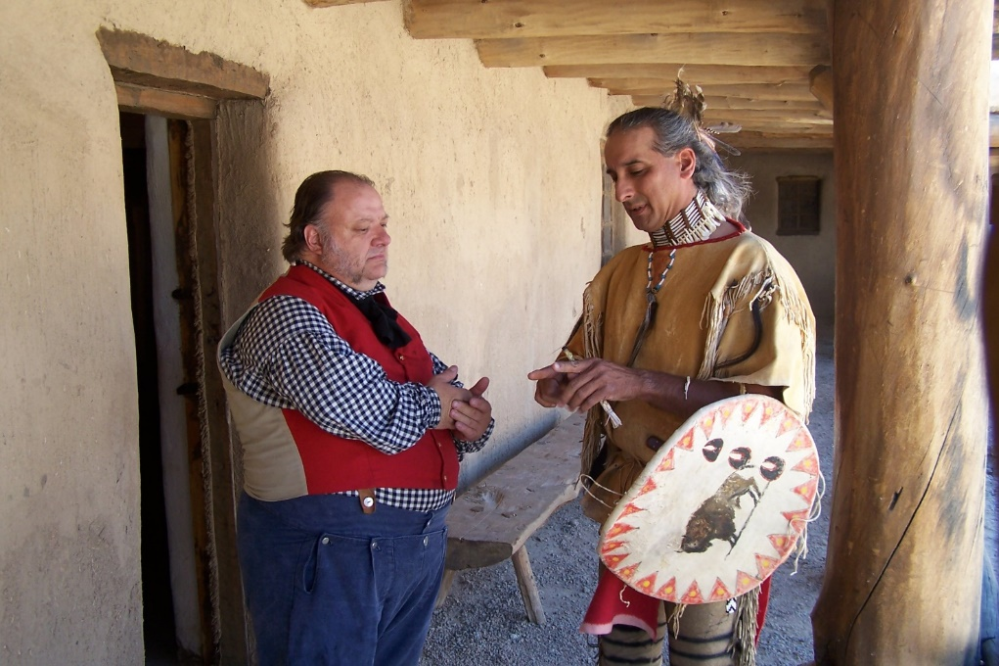

Anglo merchant and Plains Indian re-enactors

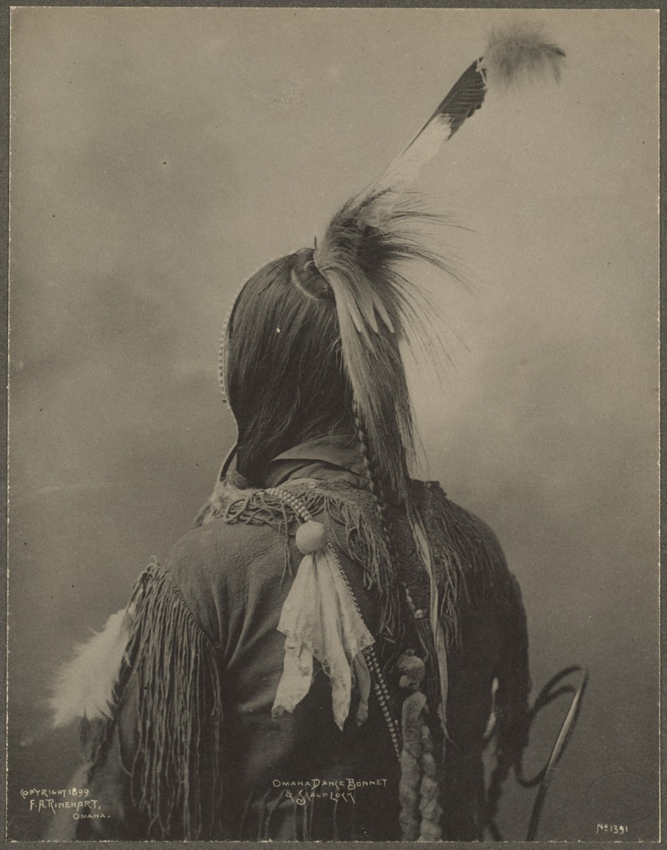

Crown lock hairstyle

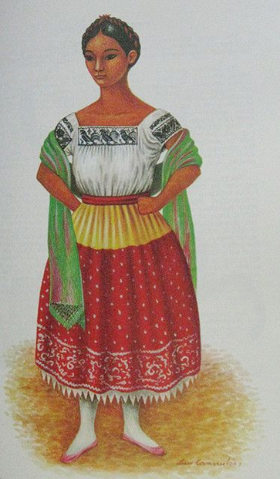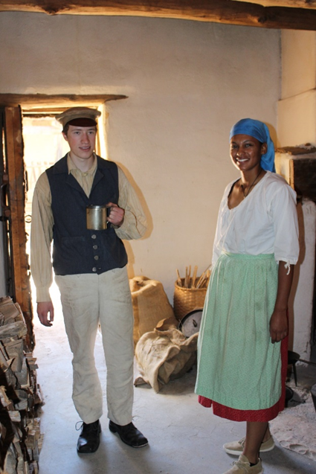

Trader and enslaved African-American re-enactors Mexican woman’s dress

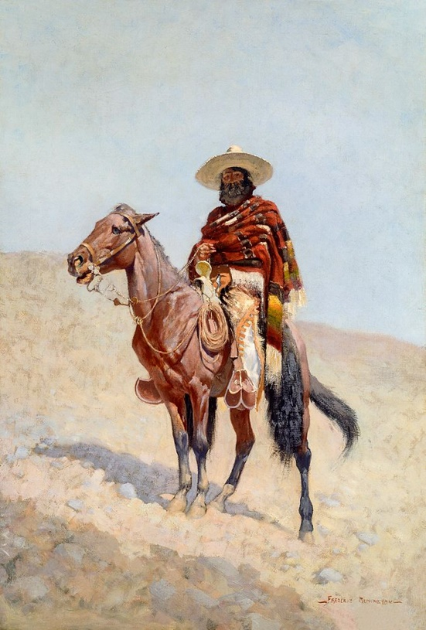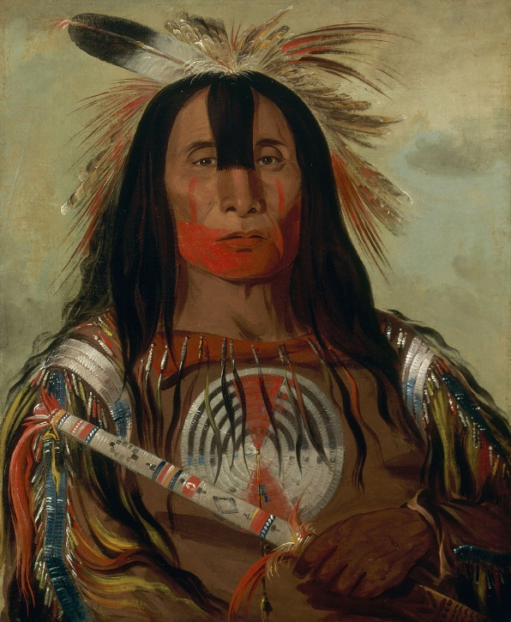

Painting of Mexican trader wearing sarape Painting of Plains Indian in red vermillion

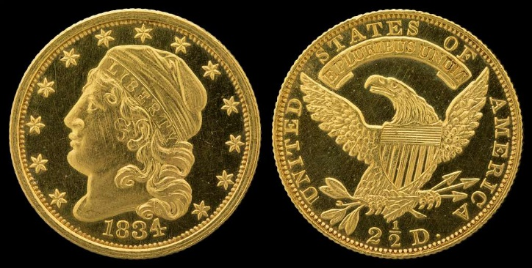

U.S. Coin Currency 1834

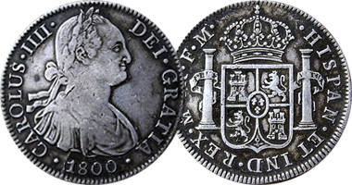

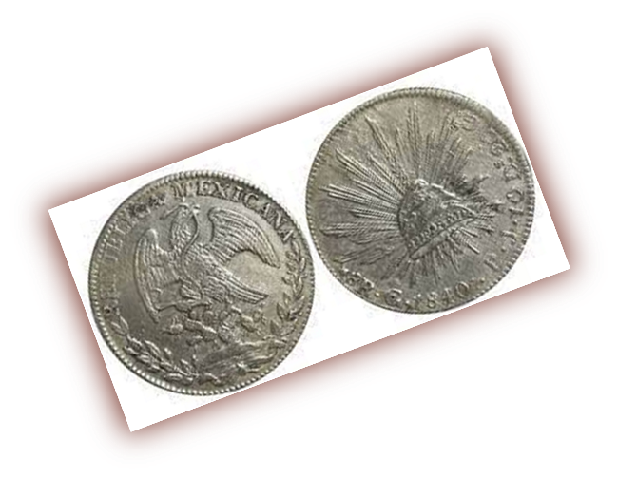 Spanish Reales 1800

Mexican Reales 1840